Mastersoft Mobile Solution’s
BRAIN SCHOOL



Congratulations for enrolling in Brain School!
Wear your school uniform in the correct manner at all times
Do not run in the corridors
Do not chew gum
ENJOY IT!

LINKS AND INDEX TO HELP CONTENTS :

INTRODUCTION

THE BRAIN AND ITS FUNCTIONING

BRAIN SCHOOL CONCEPT

EXPLANATION OF THE DIFFERENT APTITUDES TRAINED
Mental Speed
Numerical Aptitude
Logical Aptitude
Memory training
Spatial Aptitude
Verbal Aptitude
Musical Aptitude

BRAIN SCHOOL REGISTRATION

BRAIN SCHOOL GAMEPLAY

TOOLBAR

PUZZLES

DAILY EXAMS

Year 1
    - Magic Hats
    - Heavier, Heaviest
    - Simple Sums
    - Plastic Puzzle
    - Shape Maths
Year 2
    - Just Times Tables
    - Building Blocks
    - Class Register
    - Twins
    - Paper Puzzle

Year 3
    - School Trip
    - School Bus
    - Syllables
    - Number Patterns
    - Wordsworth
Year 4
    - Roman History
    - Music Lessons
    - Kakuro
    - Sudoku
    - Maze Craze

OTHER FEATURES

PAUSE FEATURE

MULTIPLE PLAYERS

SOUNDS

SCHOOL REPORTS
    - Exam Results
    - My Score
    - Class
    - Careers Advisor

PROGRESS SCREENS
    - Star System
    - Overall Progress Screen
    - Yearly Puzzles Progress Screen
    - Puzzle Level Information Screen
    - Puzzle Results Screen

EXTRA TUITION

Extra Curricular Activities
Lifestyle Tips

SUPPORT INFORMATION

INTRODUCTION

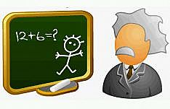

Have fun whilst at the same time helping to keep your brain performing at its optimum level. It’s been shown through study, that as well as physical fitness being important for human health, and people making sure they work on that through exercise; it’s just as vital to exercise your brain in the same way through specifically targeted exercises. This makes sure you continue operating at your peak, and also staves off ‘brain slowing’ that occurs during the ageing process. There is in fact no age limit to learning and the human brain has a great capacity to adapt depending on what ‘challenges’ it faces. The brain thrives on thinking!

This amazing organ constantly learns and grows by interacting with the world around it…. from the womb, right throughout your entire life. Before birth, the brain’s neurons are created. Once born, these 100 billion neurons are primed to respond to the world around them. These neurons connect to each other to form a neural network that makes the brain capable of making 200 calculations per second! It is this neural network that is the structural basis for the brain’s memory and thinking capacity. The more variety of different learning stimuli you fit into your life, the fitter and more agile your brain will become.
Mental stimulation of different types improves brain function and protects against cognitive decline as it has the ability to continually rewire itself when faced with new tasks and challenges, even into old age. Seems the old adage ‘use it or lose it’ couldn’t in fact be more accurate in today’s world! Studies have shown adult brain changes can be rapid …. In as little as 5 days, depending how they are used, positive changes can occur in sensory and motor skills.

This is where Mastersoft's Brain School is perfect for this task with specially targeted puzzles that specifically train the different aptitudes ….. it's the brain’s cross-trainer!
This ability of the brain to adapt when we learn anything new, or if we use a particular skill often, means that when you are challenged with puzzles that target the different aptitudes such as logic, spatial awareness and memory, you are training specific areas and skills of the brain. This is similar to the way an athlete would train different muscle groups to keep them at a physical peak. Brain School contains 20 different puzzles, each at 5 levels which increase in difficulty as your brain is progressively trained during its school attendance! It is also shown that if you learn in a way that is fun, this aids learning and retention ……. Brain School is FUN! There are no detentions, school dinners or school uniforms either which has to be good!

With so much variety you'll NEVER get bored and be tempted to play truant from THIS school!!!!

Everyone’s brain is different, and is better in different areas/ aptitudes than others. Left-handers are often different to right-handers, and men are often different to women in where their aptitudes lie; more than both of those though are the fact that people in general are different in their skills. Some puzzles you will struggle with, others you will sail through ….. regular practice and perseverance on the ones you find hard will reap satisfying rewards!

Train that brain like never before!!!!

Some information on the brain and it’s functioning;

DIAGRAM ILLUSTRATING ONE SIDE (HEMISPHERE) OF THE BRAIN’S CEREBRUM:

BROCA’S AREA PARIETAL LOBE
FRONTAL LOBE

TEMPORAL LOBE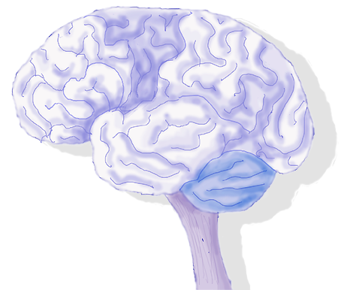OCCITIPAL LOBE

WERNICKE’S AREA

The largest part of your brain is the Cerebrum; it’s rather like the cap of a mushroom that sits atop the other parts of the brain. It’s this part of the brain that has the heavily folded, ‘wrinkled’ appearance, designed as such so that as much brain material can be fitted into the small space inside the skull.
Its Frontal Lobe is involved in: speech, thought, emotion and skilled movement.
Behind the frontal lobe is the Parietal Lobe which perceives and interprets sensations such as pain, touch and temperature.
At the centre back is the Occipital Lobe which detects and interprets visual images.
On either side of the Cerebrum are the Temporal Lobes which are involved in hearing and strong memory.
The Cerebrum is split down the middle into 2 halves (Hemispheres) that communicate with each other. These are the left and right hemispheres which are responsible for different manners of thinking.

LEFT HEMISPHERE:
Dominant in right-handers
LOGICAL
SEQUENTIAL
RATIONAL
ANALYTICAL
OBJECTIVE
LOOKS AT ‘PARTS’

RIGHT HEMISPHERE:
Dominant in left-handers
RANDOM
INTUITIVE
HOLISTIC
SYNTHESISING
SUBJECTIVE
LOOKS AT ‘WHOLES’

Therefore right-handers are often more mathematical and analytical; whilst left-handers are more creative and intuitive. Personality also comes into play here though, so that is a generalisation! Even more up for debate is the male/ female divide and where that lies when it comes to language and mathematical skills for instance; there are some much generalised differences between the sexes, but more often than not these observations are unfounded stereotypes!

THE BRAIN SCHOOL CONCEPT



Brain School is built around a system of 4 years. Each year contains 5 unique puzzles at 5 different levels. As each year increases in difficulty, so these levels 1-5 also increase in difficulty as your brain’s skills improve during its training. Once you complete a level of a particular puzzle you will be issued with a graded star …. the top achievement being an A+ star. To proceed to a following year, a requisite number of A+ stars must be obtained on that year’s Puzzles, and also a ‘pass’ in that year’s ‘Daily Exam’ This achievement will unlock the next year’s Puzzles and Daily Exam. The exams consolidate everything you’ve achieved during that year’s puzzle play, and also bring in the element of speed …. A vital element to brain training.
It doesn’t matter how long you take on each year ….. go at your own pace and enjoy it! The challenge really is to see your progression. Each previous ‘best score’ and ‘best time’ is recorded by Brain School during each puzzle, so it’s your own personal challenge to see if you can improve on them …. However long it takes! Year 4’s Daily Exam is a ‘Finals’ exam that consolidates everything you’ve learnt and the skills you’ve improved during your Brain School attendance……. Once you achieve a pass on this and the required number of stars in Year 4 you will graduate Brain School!

All these puzzles and exams can and should be repeated even if you’ve completed them previously, as then you have the challenge of improving your times!

EXPLANATION OF THE DIFFERENT APTITUDES TRAINED
..
Mental Speed:
This is a big part of intelligence which can improve with practice and allow you to achieve your maximum potential for this skill. The faster your brain works, the more likely you are to have higher intelligence all round, as it can process all information with greater speed.
Numerical Aptitude:
Numeral-mathematical intelligence is at the centre of most everyday intelligence. Mental arithmetic when shopping or calculating your bank balances and finances for example. Although the frontal lobe and many areas of the brain are active whilst performing higher mathematics, for basic counting and number pattern tasks it is most often the left interior Parietal Lobe which is utilized. Exercising this aptitude most likely exercises your entire intelligence so could be one of the most effective forms of a mental workout!

Logical Aptitude:
Logical thought; although most often associated with high-flying chess players, is actually far more mundane and vital to your everyday life. This kind of thought is utilized when programming the video recorder for example! It’s commonly believed that this type of thought is mainly learnt, and in doing so you are better able to predict and spot problems and fallacies.
Memory training:
There are 2 main types of memory: working and long-term memory.
Working memory is almost like the brains chalkboard or note pad. Where ‘works in progress’ exist …. This is utilised for ideas, mid-way calculations in arithmetic, that sort of thing. A working memory that can hold more and hold that for longer will lead to greater intelligence all round as you can perform complex mental tasks faster and better.
Long-term memory is where information is stored that was in the working memory, but that you’ve either consciously tried to remember, has been ingrained over time or that has moved there because it has some emotional attachment to it. A memory goes through stages of ‘encoding’ in the process of being stored in your long-term memory. The stronger this encoding is, the more permanent that memory will be for you. You can help this encoding be stronger by using image associations, repetitions or story associations. For example, build your set of words you want to remember into a story of a journey with a series of images and related landmarks along the way!
Spatial Aptitude:
This is to do with visual experience, for example: forms, dimensions, patterns, shapes, movement, navigation and the space they are all contained within. It’s essential to everyday tasks as you use it to decide how long it will take you to do the shopping, plan a route to see a friend, decide where to put new furniture and how it will fit in your room! For this reason it’s useful to a wide range of professions: architects, artists, sportspeople, taxi drivers and engineers to name a few! It is often thought that spatial intelligence is the core of intelligence itself as it also probably governs mental space.
There is often much debate as to whether there is a gender divide in this aptitude! Some studies do show that males tend to be more proficient in this area, but it’s widely believed that far more significant than gender is individual personality, genetic inheritance, education and nutrition. There do seem to be differences as to the way the genders approach spatial awareness though. Women tend to use landmarks more during spatial tasks and are better at picture/ object recall and also finding first letters of words. Men however seem better on average at tasks that require mental rotation or manipulation of an object.
Verbal Aptitude:
This is a core component of overall intelligence. Those with a wide vocabulary and an ability to manipulate words, grammar and language are known to have a higher intelligence. Verbal training activates the areas in the Frontal and Temporal Lobes. Two of particular importance are; Wernicke's Area (located in the temporal lobe) and Broca’s Area (at the junction between the Frontal and Temporal Lobes). Verbal aptitude is relevant to a wide variety of careers: journalists, teachers and in marketing for example. It is also an aptitude that can significantly be improved with practice ….. hence the term ‘being well read’. Reading is an excellent way to practice, as is writing (such as keeping a diary); although there are many more!

Musical Aptitude:
At its most basic level, music is sound produced by different forms of vibration. This vibration creates sound waves which are converted to movement in the middle and inner ear. This movement is then further converted into electrical signals which then travel along the cranial nerve to the brain where its final processing takes place.
The fact that music has a profound affect on the brain has been acknowledged since ancient times. This profound effect is probably due to the fact that the brain’s handling of music isn’t localized to specific areas, but the sophistication of musical processing is all pervading. Listening to, and appreciating music is a complex process that involves memory, learning and emotions.
Most people are born with an innate ‘average’ skill in music, but all have the potential to achieve in it. Whilst a few are innately gifted, and a few fall in the other end of this scale, most are average in their musical potential. This aptitude can fluctuate most significantly up to the age of 9, depending on the richness and diversity of your musical environment - after this, what you are likely to improve and maximize upon is your ‘stabilized musical aptitude’ that was reached at this age. Mathematical Aptitude seems the single best predictor of Musical Aptitude, good at one; you are likely to be good at the other!

Studies have shown that listening to Mozart (Sonata for Two Pianos in D Major) can boost your brain function …. spatial reasoning has been shown to improve as a result. Improvement has even been shown with Alzheimer’s patients .. the resulting memory and other brain improvement have become known as ‘The Mozart Effect’! It is believed that musical and spatial processing use the same pathways in the brain. Music can be seen as a brain circuitry ‘boost’! Learning to play an instrument, however, rather than just listening is widely agreed to produce the most profound improvements in brain function.
Even though Einstein is widely regarded as one of the greatest minds who ever lived, he was actually dismissed from school due to being judged ‘too stupid to learn’. Unwilling to accept this, Einstein’s parents bought him a violin, and this was the key to the development of his amazing mind. Music was what Einstein himself credited for his intelligence. His favourites were the music of Bach and Mozart.

......

BRAIN SCHOOL REGISTRATION



To enrol in Brain School, school fees must first be paid!

You can purchase and pay for your product at:
http://MastersoftMobileSolutions.com

You can then proceed to register your product and enrol for the full 4 years of Brain School.

You'll need to send your serial code (given under Menu → Help → Register) to .....
Support@MastersoftMobileSolutions.com

...... then you'll be sent back a registration code which you enter into the box, click 'register', then you're done! Your years at Brain School can commence ……….

BRAIN SCHOOL GAMEPLAY



Toolbar

Resume button: After gameplay has been paused, this will resume play at the point you left the game, allowing you to continue.
Hometime button: Quits the Brain School Game
Menu button: Click on this and the full menu is displayed; leading to other menus such as ‘Help’, ‘Options’, ‘School Reports’ which then leads you to further options such as; ‘Audio’ (Sounds on or off/ School piano on or off), ‘Pupil’ (selection of/ reset of), ‘My score’, ‘Careers Advisor’ and ‘Class’ …. These also sometimes lead onto further options again.
Quit button: Quits you from the current puzzle and takes you back to the main Overall Progress Screen.
Close Button: This closes the ‘graph’ (Exam Results) screen and takes you back to the Overall Progress Screen.
'Flip Piece' Button: Used in Plastic Puzzle to ‘flip’ the selected piece.
'Quit I'm Done' Button: Used in Class Register to exit you from the name memorising and name entry sessions which moves you onto the next stage of the puzzle quicker.
Show info/ Hide Info Button: Used in Wordsworth to hide the ‘timer’ and ‘set counter’ clocks at the top of the screen. They slightly mask the very top portion of the play area, so for this reason you might like to ‘hide’ them.
‘Undo Button’: Used in Kakuro and Sudoku to ‘undo’ the last action you performed. Press it repeatedly; it will undo a series of actions.

PUZZLES

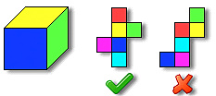

Chart your progress via the Yearly Puzzle Progress Screen and the Overall Progress Screen. Your results and progress so far will be indicated via the Star System.

Your progress can also be mapped as either ‘Score’ or ‘Level’ via ‘My Score’.

YEAR 1

Gain 5 A+ star to unlock Year 2.
Remember to practice and PASS your Daily Year 1 Exam!

MAGIC HATS
Spatial Aptitude
Mental and Visual Speed

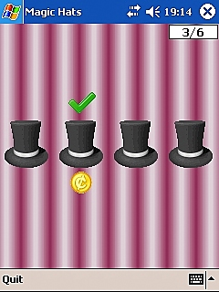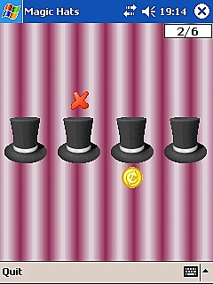

Where it ends up, it's for you to guess, combat the speed ... that's your test!

Which hat is the coin under? Track that hat and make your choice .... But you'll have to be quick!
Click on the hat you think the coin is under. Are you right? All will be revealed!

You will get a green ‘tick’ for 'correct', and a red 'X' for 'wrong', as well as an audible notification. Score will be based on how many of that set you choose correctly; how many of the set of you have completed will be shown by a counter in the top right hand corner of the screen.

As you advance through the levels the number of hats are liable to increase, as is the speed at which they shuffle, and also the number of questions contained in a set can increase.

Keep those eyes peeled!

HEAVIER, HEAVIEST
Spatial Aptitude
Logical Aptitude

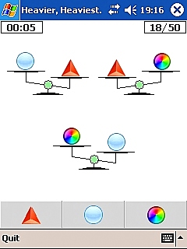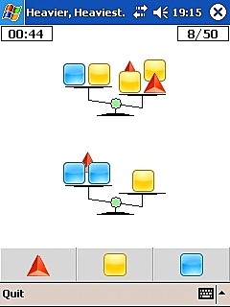

Where the scales balance, gives you the clue ……. which is the heavier, it’s up to you!

Weigh up the options .... which object is heaviest?

Look at the picture of the balance scales, make your choice and enter your answer by tapping the corresponding symbol of your choice from the icons along the bottom of the screen. These icons change, as do the numbers involved which increases the complexity!

A big green ‘tick’ or a big red ‘X’ with a corresponding sound will inform you if you are right or wrong with your answer.

Chart your progress via the counter in the top right hand corner of the screen which shows how many of the set you have completed and a countdown timer in the top left of the screen which indicates how much time you have remaining in which to complete the set of questions.

The amount of balance scales/ complexity of the questions increase through the levels. When there is more than 1 balance scale shown there is still only one shape icon that is the answer; you must work out which one this is using all the visual information provided!

Are you right? Have the scales tipped in your favour?

SIMPLE SUMS
Numerical Aptitude
Working Memory

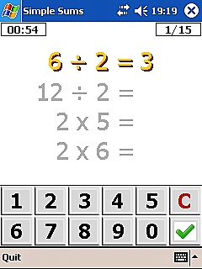

Mental arithmetic is the name of the game …. add them up … and feel no shame….

Dust that rust off those brain cells and be prepared for some quick-fire arithmetic!

Calculate the answer, then input this using the keypad at the bottom of the screen .... Click the green ‘tick’ located bottom right to confirm your answer. If you make a mistake with your entry, then click the 'C' button just above the green ‘tick’ and it will clear your selection for you and you are free to re-enter it correctly. Are you right? The sound will tell you, but no time for glory or tears .... it's onto the next.

Chart your progress via the counter in the top right hand corner of the screen which shows how many of the set you have completed, and a countdown timer in the top left of the screen which indicates how much time you have remaining in which to complete the set of questions.

PLASTIC PUZZLE
Spatial Aptitude
Logical Aptitude
Working Memory

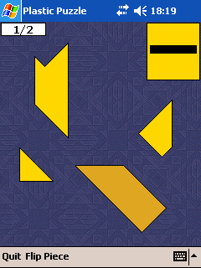

AIM
SHAPE MOVEMENT
  - Selection
  - Dragging
  - Flip
TIMER

Manipulate the pieces to make the black shape … which bits fit where …. it’s never too late!

Your aim is to make the black shape shown in the yellow box in the top right hand corner of your screen. Use the yellow pieces provided in the main screen. First you will need to select the piece you wish to manipulate into its correct position.

You can manipulate each piece by;
Selection: You need to select any piece in order to move it. Once clicked, that piece will be isolated from the rest and will show you've selected it by turning from yellow to brown. To deselect, just click on one of the other pieces.
Dragging: Click and drag with your stylus to move it into the position you require.

Rotating: Draw in a circular motion with your stylus around the outside of the selected piece so it swivels round and rotates.
Flip: This flips the piece back and forth in the opposite direction. Select the piece you wish to flip, turning it brown. Click the 'Flip Piece' button on the bottom Toolbar

A stage display at the top left of your screen charts how many of the set you have completed successfully. Time is limitless on this one, but when you complete a Plastic Puzzle step, be sure to absorb and remember how you did it. If you don’t complete that level’s set in one sitting you will be asked to repeat that step in order to proceed onto the one you previously failed on!

You will be given a green ‘tick’ when you have completed a particular shape correctly.

SHAPE MATHS
Spatial Aptitude
Logical Aptitude
Working Memory

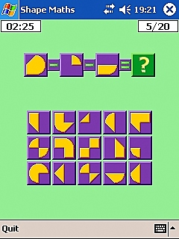

The segments are given, perform the sum ……. what will the shape look like, when all is done?!

It's maths, but with shapes ...... it's Shape Maths!

Shape segments are shown in yellow on a background of a purple square toward the top portion of your screen. Between these purple squares are the sums you will need to perform on the yellow segments within these purple squares; ' + ' and ' - ' ...... Once you have decided what form the resulting yellow segment will take after the calculation, and you have your ' = ' answer, you click the purple square that contains the yellow form which matches your vision, from the multiple choices below the sum.

A big green ‘tick’ or a big red ‘X’ with a corresponding sound will inform you if you are correct with your answer.

Chart your progress via the counter in the top right hand corner of the screen which shows how many of the set you have completed and a countdown timer in the top left of the screen which indicates how much time you have remaining in which to complete the set of questions.

Are you right or are you wrong? No time to ponder as you must move on!

YEAR 2

Gain 15 A+ stars (in total) to unlock Year 3.
Remember to practice and PASS your Daily Year 2 Exam!

JUST TIMES TABLES
Numerical Aptitude

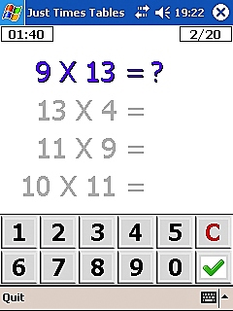

Solve the times tables, as quick as you can ….. fast but accurate though, that's the plan!

Remember the chants at primary school you had to repeat in unison; "1x1 is 1, 2x1 is 2, 3x1 is 3 ....."? Well THIS will refresh those fond memories and bring on that warm glow of nostalgia!

More than that, however, this will test your multiplication skills as it goes far beyond 12x12!

Calculate the answer, then input this using the keypad at the bottom of the screen .... Click the green ‘tick’ located bottom right to confirm your answer. If you make a mistake with your entry, then click the 'C' button just above the green ‘tick’ and it will clear your selection for you and you are free to re-enter it correctly.

Chart your progress via the counter in the top right hand corner of the screen which shows how many of the set you have completed and a countdown timer in the top left of the screen which indicates how much time you have remaining in which to complete the set of questions.

Are you right or are you wrong? The sound will tell you, then it's onto the next one!

BUILDING BLOCKS
Numerical Aptitude
Spatial Aptitude
Working Memory

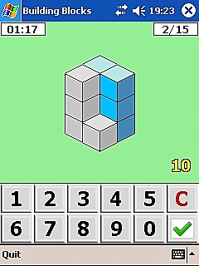

Build the structure in your mind, how many blocks can you find?

Tests the mind’s capacity to form models, and your ability to look at 2 dimensional shapes and visualize them as 3-dimensional.

Calculate the number of blocks required to build the form shown; some are visible to count, the rest are hidden from the eye (behind the others). You will have to calculate the total number of blocks required for the structure from the visible clues; completing the block count from the structure shown with your mind’s eye.

Add them together, then tap the corresponding figures from the keypad along the bottom of the screen. When you are happy your figure has been inputted correctly (shown just above the keypad, at the right, in yellow), then click the green ‘tick’ located bottom right. If you make a mistake, then click the 'C' button just above the green ‘tick’ and it will clear your selection for you and you are free to re-enter it correctly.

A big green ‘tick’ or a big red ‘X’ with a corresponding sound will inform you if you are right or wrong with your answer.

Chart your progress via the counter in the top right hand corner of the screen which shows how many of the set you have completed and a countdown timer in the top left of the screen which indicates how much time you have remaining in which to complete the set of questions.

CLASS REGISTER
Memory Training
Verbal Aptitude

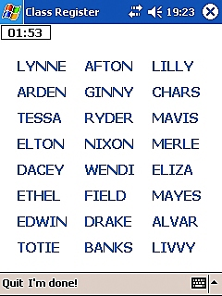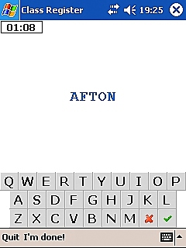

‘Here Sir’, they shout, as their name is read out ….. recalling them though, that’s what this one’s about!

Your working memory is the name of the game here; and the testing of it, by asking you to recall from it.

On the first Class Register screen you are given a list of pupil names from the Brain School class. These you are to look at and memorise for a period of time shown by a countdown timer at the top left of the screen. Once this period of time has elapsed you are taken to a second Class Register screen which contains a ‘QWERTY’ letter layout keyboard. Your challenge is then to input each recalled name in turn, followed by clicking the green ‘tick’ on the keyboard when you are satisfied your selection has been entered as you'd like.
If you make a mistake, and wish to re-enter your answer, then click the red 'X' which will clear your inputted letters thus far; you are then free to re-input as you wish.

If you prefer not to wait for the given time to elapse during your name memorising/ entry sessions, then there is a 'Quit I'm done' button located on the Toolbar.
When you think you’ve remembered all the names you possibly can on the names intro screen, click this button, which will take you straight to the names entry screen. Once you have entered all the names you can recall on this screen and can't think of any further ones (and the given time hasn't run out), then hit this button again, which will take you to your puzzle results screen.

Once again you are timed and your challenge is to recall as many names as you can before the time runs out! Your progress time-wise is once again charted by a countdown timer in the top left of the screen.

Your grade is based upon how many names you have managed to recall and input correctly.

Once you click the green ‘tick’ on the keyboard to confirm your answer you are given one of 3 notifications:

Green ‘tick’: Answer is correct and will count toward your final score. Proceed to input the next remembered pupil’s name!
Red 'X': Answer is incorrect, please try another name.
'Already Entered': This pupil’s name has already been entered correctly previously, and therefore this entry cannot count toward your final score.

The number of names you are asked to recall from increase through the levels, as does the number it is necessary to remember correctly for an A+ star.

TWINS
Memory Training
Spatial Aptitude

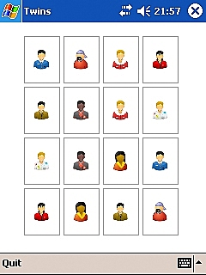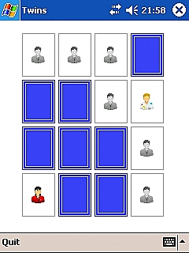

Do my eyes deceive me, I’m seeing double …. remembering their position though …. that’s the trouble!

You are faced with a grid of pictures of the different sets of twins attending Brain School; each twin picture having its double (identical image). You have a certain number of seconds (told to you on the intro screen) in which to memorise as many twins as you can. The picture cards are then all turned over to their blue sides so all the pictures in the grid are obscured. Click on one of the blue cards, the picture will be revealed. Once you have decided in which position its twin lies, then click on the corresponding blue card in the position you've chosen. The chosen card will flip round and reveal if you are right! If you are correct then both pictures will turn from colour to black and white to show they are complete and correct. If you are incorrect both cards will flip back to their blue sides.

Either way, right or wrong, you continue to guess the positions of all the Brain School twins until every picture icon are showing, and in black and white. How many moves it has taken for you to find all the twins will determine your score.

The number of picture squares increase as you go up the levels. The better your memory, the fewer moves you will take to find all the twins and the higher your resulting score.

PAPER PUZZLE
Spatial Aptitude
Logical Aptitude
Working Memory

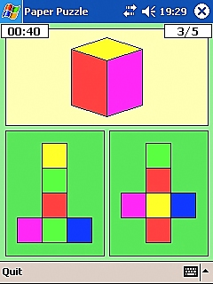

Fold in your mind, that's what you're told ..... create the polygon .... your result will behold!

This tests mental rotation. With an object in real life, you have the ability to pick it up, rotate it in your hand and examine the angle involved. With a puzzle such as this, you are forced to rotate and examine it mentally.

Work out which of the pieces of paper, when folded, will create the polygon in the main picture.

The unfolded paper choices are shown below the main polygon shape picture you have to create. Choose the one, that once folded will create the polygon, then tap it to input your answer. If you are right, a big green ‘tick’ will appear, if you are wrong a big red 'X' will appear, a corresponding sound for each is also audible.

Chart your progress via the counter in the top right hand corner of the screen which shows how many of the set you have completed and a countdown timer in the top left of the screen which indicates how much time you have remaining in which to complete the set of questions.

The number of unfolded paper piece options increase as you advance through the set.
The types of polygons to create change as the levels increase in difficulty.

YEAR 3

Gain 30 A+ stars (in total) to take the year’s exam and unlock Year 4.
Remember to practice and PASS your Daily Year 3 Exam!

SCHOOL TRIP
Working Memory
Spatial Aptitude

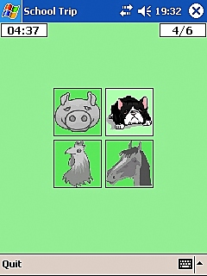

See the animals light up in sequence; hear their noises and how often they frequent!

This will test and train your working memory.

You are faced with a grid containing pictures of animals. Each of these pictures might light up, turn from black + white to coloured, and will also make their associated sound (i.e. Sheep ...... 'baaa ...') at the same time. This happens in a random sequential pattern which differs each time. Your challenge is to recall this exact sequence in the way it was first played to you by tapping each animal picture in the same pattern. For example... The cow lights up and goes 'mooo' twice; you then tap the cow in that same position twice to repeat that same sequence.

When you have mimicked the sequence correctly, the animal will baaa, mooo, bark etc. once more and a green 'tick' will appear. Then the next animal sequence will start for you to repeat. As soon as you repeat the sequence incorrectly (by tapping the wrong animal picture); a red 'X ' will appear and the game will end there! Your final score will be based on how many you repeated back correctly (up to the maximum required for an A+ star) before the game ends!

Chart your progress via the counter in the top right hand corner of the screen which shows how many of the set you have completed and a countdown timer in the top left of the screen which indicates how much time you have remaining in which to complete the set of questions.

The number of animal pictures contained in the grid, and the sequence complexity increase as you go up through the levels and the puzzle gets harder.

A pig goes 'oink', a cow goes 'mooo' .... recall the sequence it's up to you!

SCHOOL BUS
Working Memory
Numerical Aptitude

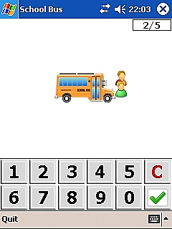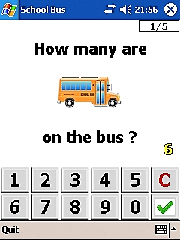

Counting the pupils on and off the bus ...... keeping track of the number, now that's a must!

This will train your working memory and mental arithmetic skills.

The school bus zooms into view on your screen and comes to a halt. A number in green is then displayed on the bus to tell you how many pupils are currently on there. Then pupils appear, either departing or joining the bus .... You keep track of these by either adding (joining pupil) or subtracting (departing pupil) from the original pupil count you were given as being on the bus.

Input your answer using the keypad at the bottom of the screen .... Click the green ‘tick’ to the bottom right which confirms your answer. If you feel you are wrong and would like to re-input your answer, then click the 'C' at the top right of the keypad, which resets to 'clear'; you can then re-input your answer correctly.

Your entered answer will show in yellow above the top right hand corner of the keypad. Click the green ‘tick’ to confirm your answer. If you are right a big green ‘tick’ will appear, and you are taken on to complete the next one of the set. If you are wrong a red 'X' will appear; the correct answer will be shown in green on the school bus . You are then moved on to complete the next one of the set to hopefully have better luck this time!

A counter in the top right hand corner of the screen will display how many of the set of questions for that level of School Bus you have completed correctly. Your Brain School puzzle grade will be based on that number.

The pupils departing and joining the bus increase in number and speed as you advance through the levels.

SYLLABLES
Verbal Aptitude
Numerical Aptitude
Working Memory

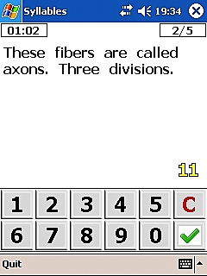

Split each word to its syllable core ..... add them together to produce your score!

Syllables are probably best explained as ‘chunks of sound’. A syllable is a sound that can be said without interruption. EVERY word contains at least one syllable. A syllable can consist of a single letter, or a series of letters. What always distinguishes a syllable is a ‘sound break’, or a ‘beat in the sound’. It can help to spot them by saying the word out loud, and also to clap on each sound break (if nobody else is around to hear you!).

In English, a syllable usually contains a vowel (A, E, I, O, U) or a ‘Y’.

Some syllables are frequently used in lots of words. For example:
ly ……. Ear/ly, late/ly, cru/cial/ly, cer/tain/ly, ex/pe/ri/men/tal/ly
tion ….. lo/tion, sta/tion/a/ry, ac/tion, in/for/ma/tion
A word that combines the 2: E/mo/tion/al/ly

In Brain School ‘Syllables’ you are given sentences displayed on your screen. Split each word in this sentence into its syllables, then add the syllables you have counted in each word together to make your sentence syllable count; this number is your answer. If you are given more than one sentence, proceed to add all your sentence syllable counts together to produce your answer.

Once you have your answer, tap the corresponding figures from the keypad along the bottom of the screen. When you are happy your figure has been inputted correctly (shown just above the keypad, at the right, in yellow) then click the green ‘tick’ located bottom right. If you make a mistake, then click the 'C' button just above the green ‘tick’ and it will clear your selection for you and you are free to re-enter it correctly.

Once you have confirmed your inputted answer, you will see the syllables being counted up by the program to the left of your answer in green figures. When it has finished counting the correct answer will be displayed here in green. If you are right a big green ‘tick’ will appear, and you are taken on to complete the next one of the set. If you are wrong a red 'X' will appear, you are then moved on to complete the next one of the set.

NUMBER PATTERNS
Numerical Aptitude
Logical Aptitude
Working Memory

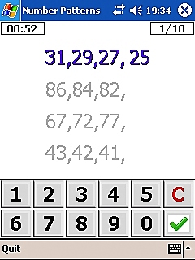

Work out the running theme, amongst the numbers, that's the scheme!

This is a logical progression test.

You have to work out the number that comes next in the sequence. Work out the sequence from how each number differs from its neighbour. The one that's missing, and next in the sequence is the one you calculate, and therefore becomes your answer.

Input your answer using the keypad at the bottom of the screen .... Click the green ‘tick’ to the bottom right which confirms your answer. If you feel you are wrong and would like to re-input your answer, then click the 'C' at the top right of the keypad, which resets to 'clear'; you can then re-input your answer correctly.

Chart your progress via the counter in the top right hand corner of the screen which shows how many of the set you have completed and a countdown timer in the top left of the screen which indicates how much time you have remaining in which to complete the set of questions.

Are you right or are you wrong? The sound will tell you, then it's onto the next one!

WORDSWORTH
Verbal Aptitude
Spatial Aptitude

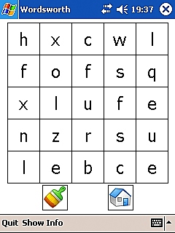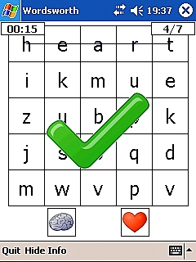

"The answer is me, the word hidden amongst the letters ... where am I ..... and am I forwards or backwards?!"

Find the word hidden in the letter grid. Click the corresponding picture that matches that word.
The word can be hidden forwards, backwards, horizontally and vertically ....... so keep your eyes peeled!

Key to the picture icons and their associated words:

 AMBULANCE APPLE  AUCTION HAMMER
 BANANA  BATTERY  BASKETBALL
 BELL  BOAT  BOOK
BOTTLE  BRAIN  BRUSH
 CAMERA CANDLE CASTLE
CHAIR  CHEST  CLOCK
COCKTAIL  DOG  COFFEE BEAN
 EYE  FLOWER  FLASHLIGHT
 GHOST  GUITAR  HEART
 HOUSE  KEY ICE CREAM
 KNIGHT  MAGNET  HOURGLASS
 MUSIC  PALM PINEAPPLE
PLANET  RADIO ROBOT
 SCALES  SNOWFLAKE  SPORTSCAR
 SUN  TREE  TELESCOPE
 STEP  VIOLIN  STOPWATCH
 TENNIS BALL  NEWSPAPER

NOTE:
2 Words showing a space between on the key have NO spaces within Wordsworth. i.e: TENNISBALL

If you are correct a big green ‘tick’ will appear, and the word becomes ‘highlighted’ by having a blue line struck through it. If you are wrong a red 'X' will appear and you will be moved on to the next screen.

Chart your progress via the counter in the top right hand corner of the screen which shows how many of the set you have completed and a countdown timer in the top left of the screen which indicates how much time you have remaining in which to complete the set of questions. If you would like to ‘hide’ these 2 counters as they slightly mask the very top portion of the play area, you can click the ‘Hide Info/ Show Info Button’ located on the bottom toolbar. When the counters are showing on your play screen, this button will appear as ‘Hide info’; you click it once, then both counters will disappear from the screen and the button will then change to ‘Show Info’. If you would once again like to view the counters on your play screen, then just click this ‘Show Info’ button once, and like magic, they reappear!

How many you get right will determine your score.

The number of letter squares within the grid increase as the levels get harder, as do the number of picture (word) options to choose from.

Your powers of observation and a beady eye are key!

YEAR 4

Gain 60 A+ stars (in total) to take the year’s graduation exam!
Remember to practice and PASS your Daily Year 4 FINALS Exam!

ROMAN HISTORY
Numerical Aptitude
Working Memory

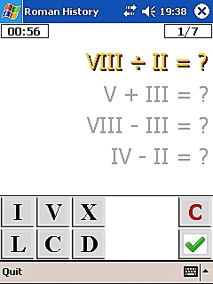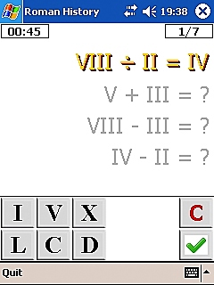

The Romans lived their life with great flair ….. can you do their arithmetic …… try if you dare!

AIM:
ROMAN NUMERAL KEY:
  - Character Key
  - Numeral Example

Transport yourself back to the time of Julius Caesar and the Romans ..... And how they would have done arithmetic!!

Sums .... but in Roman Numerals! Calculate the answer, then input this using the keypad at the bottom of the screen. If you need more than one of the particular numeral, then click it the amount of times that you need .... Click the green ‘tick’ to the right to confirm your answer. If you feel you are wrong and would like to re-input your answer, then click the 'C' at the top right of the keypad, which resets to 'clear', you can then re-input your answer correctly.

Chart your progress via the counter in the top right hand corner of the screen which shows how many of the set you have completed and a countdown timer in the top left of the screen which indicates how much time you have remaining in which to complete the set of questions.

Are you right? The sound will tell you, but no time for reflection .... as it's onto the next!

Key to the Roman Numerals:

ROMAN NUMERALS USE A BASIC SET OF 7 SYMBOLS

I = 1 (ONE)
V = 5 (FIVE)
X = 10 (TEN)
L = 50 (FIFTY)
C = 100 (ONE-HUNDRED)
D = 500 (FIVE HUNDRED)
M = 1000 (ONE THOUSAND)

Multiple symbols can be used to produce numbers in between these values. Whether these extra numerals precede or follow the higher value symbol decides whether these extra numerals are added or subtracted from this higher value numeral.

FOR EXAMPLE:

II = 2
III = 3
IV = 4
VI = 6
VIII = 8
IX = 9
XLVII = 47
XLIII = 43
LXII = 62

MUSIC LESSONS
Musical Aptitude
Working Memory
Spatial Awareness

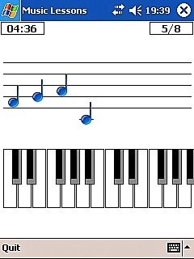

The melody is played for you to repeat back ..... tickle those ivories, but can you keep track?!

You are given a piano keyboard; above which a (blank) musical score is displayed. A musical note is played by the program which you will hear audibly. At the same time the corresponding note key is illustrated in green on the keyboard and the note is also displayed on the musical score above - briefly in green as that note is playing, turning to blue when that note has completed playing. The musical notation then disappears from the score and you are asked to repeat back the melody exactly as it was previously played to you by tapping the corresponding keys on your piano keyboard. The musical notation will once again be displayed on the musical score above (in exactly the same manner as before) as you play your tune. When you have repeated your tune correctly a green 'tick' will appear. If you are wrong a red 'X' will appear and your music lesson will end there as you will be exited from the puzzle.

The string of notes (tune) gets longer as you travel through the set to complete that Music Lesson’s level. The tune is made up from the previous notes played and a new note(s) gets added as you advance through each question of the set, thereby making the melody more complex.
As you advance through the levels, the amount of notes added during each set increases, as do the number of sets required to complete each Music Lesson’s level.

The tune will increase by 1, 2 or 3 notes at a time depending on the level you are on. For example: on level 3, you must remember the 3 extra notes, as well as the previous repeated ones to score the ONE point for that sequence (question) in the set of that Music Lessons level. Therefore you will need to correctly repeat back every note (old and new) in the tune for your score to count! A point is only awarded for repeating back correctly the entire sequence of notes.

Chart your progress via the counter in the top right hand corner of the screen which shows how many of the set you have completed, and a countdown timer in the top left of the screen which indicates how much time you have remaining in which to complete the set of melody repetitions for that level of ‘Music Lessons’.

If you are musical you will have an advantage as you will recognise each note played; if you are not you will be relying solely on your working memory to mimic the melody. These are 'Music Lessons' however, so hopefully you will absorb some extra musical aptitude along the way and discover your Rachmaninov within!

KAKURO
Numerical Aptitude
Logical Aptitude

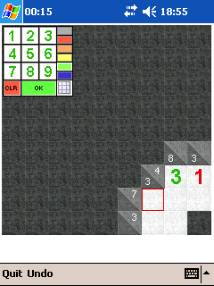

Add up the numbers in a run, they all must equal the outer sum!

In order to complete a Kakuro puzzle, you will need to employ your logical reasoning skills, like in SuDoku. Kakuro though, adds in the need to also use some numerical thinking, although all that is really required is basic arithmetic. The logical processes involved in both are similar, but at the same time subtly different …… in doing both you maximize your training of the different types of logical thinking; almost like a logical reasoning cross-trainer!

Aim of the Game
Kakuro Terminology
Getting Started
Timer
Toolbar Buttons
The Keypad
Unique Combinations
Tips

AIM OF THE GAME

Kakuro (also known as Cross Sums) resembles a 'crossword' game, but uses numbers instead of letters.
Fill each cell with a number so that the rows and columns add up to the required sum shown, without repeating the same number in any row or column.

Row:
This row requires 3 different numbers that add up to 10. So ... 1 + 3 + 6 is possible, but 2+2+6 is not since the number 2 is repeated.

Column:

A Kakuro row or column 'run' can be up to 9 cells long in theory. In Mastersoft Kakuro, runs are limited to a maximum length of eight numbers. Kakuros involving long runs can be extremely difficult.

KAKURO TERMINOLOGY:

Cell - the empty squares where you have to put the answers.
Target - the small number at the beginning of each row or column which tells you what the numbers in the cells have to add up to e.g. shows two targets; 17 for the run across and 3 for the column down.
Run - the group of cells in a row or column (minimum 2, maximum 9) that form a solution.
Combination - a group of numbers that can be placed in a Run to add up to the target. There may be more than one possible combination for a run.
Candidates – the possible solutions for a single cell.
Unique Combination - a target and run which only has one possible combination.
Naked Single - a cell which only has one possible candidate.

GETTING STARTED

There are five levels of play: Easy, Medium, Hard, Very Hard and Master. If you are new to Kakuro, even the Easy levels may seem a little difficult at first, but if you take a few simple steps at the beginning, you'll be solving them in no time: First of all, review this Help information to understand how Kakuro works (if you are used to Sudoku, be aware that the principles of solving Kakuro are quite different from Sudoku). Second, familiarize yourself with the list of Unique Combinations. They are a critical part of the initial solving of Kakuro puzzles.

TIMER:
A counter charts your progress, timewise during your Kakuro gameplay. It is located on the top toolbar.

TOOLBAR BUTTONS:
Resume: Located on the bottom toolbar. Resumes gameplay if it has been suspended while you take a phone call or similar episode occurs on your device.
Undo: Located on the bottom toolbar. To undo your last action. Press repeatedly to undo a series of actions.

THE KEYPAD:
Use the keypad to enter numbers or candidates onto the puzzle. Click in a cell where you want to enter a number and the keypad will open. You can drag it to a different position if you wish.
- Standard number entry:

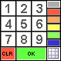
When the bottom right icon on the Keypad shows a grid you can enter standard numbers. These are the numbers that you consider are correct. You can select different colors for different numbers, a feature that many advanced players find useful.

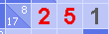
When in Standard mode the keypad will disappear as soon as you select a number key and the cell will then contain the selected value.
If you wish to clear the cell then click the CLR button.

- Candidate mode:

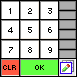
Click the bottom right icon and it changes to a zoomed in cell with a small pencil icon. Additionally, the size of the numbers on the keypad will change to indicate whether you are in Standard mode or Candidate mode. You can now enter any or all of the numbers 1 to 9 into the one cell. Use this feature to enter the numbers that you consider to be possibilities when you are not certain of the correct number.

When in Candidate mode the keypad will remain even though you have selected a number (or picture). This is because multiple selections are possible. Clicking the CLR button in Candidate mode will clear all your candidate entries for the particular cell.
Simply click on another cell to confirm your entries and continue entering more candidate numbers or click the OK button to confirm your entries and close the keypad.

UNIQUE COMBINATIONS

One of the key techniques for solving Kakuro is to be able to recognize runs which have a unique combination. For instance, if you have a target of 16 in 2 cells the only possible combination is 7 + 9. You don’t know which cell contains the 7 and which contains the 9 but you do know that those two numbers will appear in those two cells so you may want to enter them as candidates.

Here are the unique combinations (which you will soon learn to look out for). As the lower level puzzles only use short runs you only need to learn the first few to begin with. As the puzzles get bigger you’ll need to learn to recognize the rest.

For example, a target number of 3 and two cells = {1,2}.
More examples:
4 in 2 = {1,3}
16 in 2 = {7,9}
17 in 2 = {8,9}

6 in 3 = {1,2,3}
7 in 3 = {1,2,4}
23 in 3 = {6,8,9}
24 in 3 = {7,8,9}

10 in 4 = {1,2,3,4}
11 in 4 = {1,2,3,5}
29 in 4 = {5,7,8,9}
30 in 4 = {6,7,8,9}

15 in 5 = {1,2,3,4,5}
16 in 5 = {1,2,3,4,6}
34 in 5 = {4,6,7,8,9}
35 in 5 = {5,6,7,8,9}

21 in 6 = {1,2,3,4,5,6}
22 in 6 = {1,2,3,4,5,7}
38 in 6 = {3,5,6,7,8,9}
39 in 6 = {4,5,6,7,8,9}

28 in 7 = {1,2,3,4,5,6,7}
29 in 7 = {1,2,3,4,5,6,8}
41 in 7 = {2,4,5,6,7,8,9}
42 in 7 = {3,4,5,6,7,8,9}

For the longer runs it’s easier to work out what’s missing. There are no runs of 9 cells in Mastersoft Kakuro but if there were they would have to contain all of the numbers from 1 to 9 and therefore will always add up to a target of 45. A run of 8 cells will have one of the numbers missing and you can work out which one it is by subtracting the target from 45. e.g. a target of 40 in 8 will contain all the numbers from 1 to 9 except 5.

TIPS

To begin solving Kakuro one of the techniques you may find useful is to look for runs with unique combinations which cross each other. Here’s a simple example

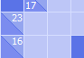
We have a 16 in 2 run crossing a 17 in 2 run which both have unique combinations. The 16 in 2 has candidates of 7 and 9, the 17 in 2 has candidates of 8 and 9 so we know that the cell where they cross must contain a 9 as this is the only common number. Then we can quickly fill in the other numbers.

You can extend this technique to help solve crossing runs which don’t have unique combinations. For instance a run of 14 in 2 has more than one possible combination – {5,9} or {6,8} and you may want to record the candidates for the two cells as 5,6,8 and 9 but if it crosses a run of 16 in 2 (which only has {7,9} as a possible combination) you can then deduce that the cell where they cross must contain a 9 as this is the only candidate which appears in both sets.

* PLEASE NOTE:
If you like this simplified version of Kakuro you may wish to consider upgrading to the full version of Mastersoft Kakuro which has many unique features that you will not find in any other Kakuro program!

Find out about Mastersoft Kakuro at http://mastersoftmobilesolutions.com/products.php

SUDOKU
Logical Aptitude

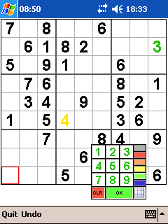

Although there are numbers, there isn’t a sum ……. placing of numbers is the key to this one!
Sudoku is an excellent means of testing your logical and reasoning capabilities, and as such should be a staple element of ‘brain training’!

Aim of the Game
The Built In SuDokus
Getting Started
Toolbar Buttons
The Keypad
Timer
Tips

AIM OF THE GAME
SuDoku is a number placement puzzle based on an 18th century invention by the Swiss mathematician Leonhard Euler. It has grown in popularity in Japanese puzzle books over the last 20 years and since the puzzles began to appear in western newspapers in late 2004 it has taken the World by storm!

So what does it involve?
SuDoku means ‘single number’. Simply fill the cells with the numbers 1 to 9 so that each column, row and 3x3 box contains each number once and only once. Although numbers are typically used you don’t need mathematical skills, just logic.
Sounds easy doesn't it?
But remember ... the simplest puzzles are often the hardest and most addictive ...

The numbers that initially appear are fixed and colored black. It is now up to you to complete the missing numbers. There is ONLY one answer!

SUDOKU TERMINOLOGY

Cell - the empty squares where you have to put the answers.

Row – a horizontal run of 9 cells

Column - a vertical run of 9 cells

Box – an area which is 3 cells wide and 3 cells high.
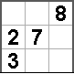

Each row, column and box contains 9 cells and there are 9 rows, columns and boxes.

THE BUILT-IN SUDOKUS
The SuDoku generator built into Mastersoft SuDoku creates 100% genuine SuDokus, each with one solution only. When creating a SuDoku, Mastersoft SuDoku solves it first in the background in the same way that a human would. This ensures that SuDokus created are appropriate to the level selected. This 'smart' way of creating SuDokus is (currently) unique to Mastersoft SuDoku!

GETTING STARTED
There are five levels of play: Easy, Medium, Hard, Very Hard and Master. If you are new to SuDoku, even the Easy levels may seem a little difficult at first, but if you take a few simple steps at the beginning, you'll be solving them in no time: First of all, review this Help information to understand how SuDoku works! These tips are a critical part of the initial solving of SuDoku puzzles. The higher level puzzles may require more advanced techniques but the ones described here should be sufficient to get you started.

TOOLBAR BUTTONS
Resume: Located on the bottom toolbar. Resumes gameplay if it has been suspended while you take a phone call or similar episode occurs on your device
Undo: Located on the bottom toolbar. Will undo your last action. Press repeatedly to undo a series of actions.

TIMER:
A counter charts your progress, timewise during your Kakuro gameplay. It is located on the top toolbar.

THE KEYPAD
Use the keypad to enter numbers or candidates onto the puzzle. Click in a cell where you want to enter a number and the keypad will open. You can drag it to a different position if you wish.

- Standard number entry:

When the bottom right icon on the Keypad shows a grid you can enter standard numbers. These are the numbers that you consider are correct. You can select different colors for different numbers, a feature that many advanced players find useful.

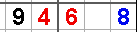
When in Standard mode the keypad will disappear as soon as you select a number key and the cell will then contain the selected value.
If you wish to clear the cell then click the CLR button.

2. Candidate mode:

Click the bottom right icon and it changes to a zoomed in cell with a small pencil icon. Additionally the size of the numbers on the keypad will change to indicate whether you are in Standard mode or Candidate mode. You can now enter any or all of the numbers 1 to 9 into the one cell. Use this feature to enter the numbers that you consider to be possibilities when you are not certain of the correct number.

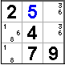
When in Candidate mode the keypad will remain even though you have selected a number (or picture). This is because multiple selections are possible. Clicking the CLR button in Candidate mode will clear all your candidate entries for the particular cell.
Simply click on another cell to confirm your entries and continue entering more candidate numbers or click the OK button to confirm your entries and close the keypad.

TIPS

To begin solving SuDoku there are a couple of techniques which you should familiarize yourself with.

The first technique (known as Hidden Single) involves choosing a number and trying to decide where it must go. It’s a good idea to start with a number which appears most often in the SuDoku. In this example we will try to place the number 6.
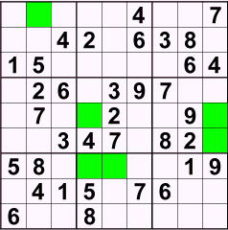

Each row, column and box must contain a 6 (and only one 6). The top left box needs to have a 6 but it can’t appear in the first or third columns as they already contain a 6. Similarly the second and third rows already contain a 6 so the only cell which can contain the 6 is the one highlighted (first row, second column). The cells which could contain a 6 have been highlighted. In some cases there are two possibilities but placing one 6 (in the centre middle box) will eliminate other possibilities and we can place the rest with certainty.

The second technique (known as Naked Single) is to choose a cell and work out which number must go in there. Let’s look at the highlighted cell (first row, eighth column).
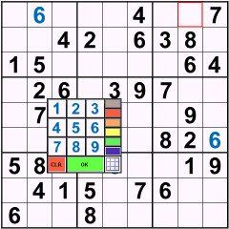

We can work out which number must go in there by eliminating numbers which already appear in the same row, column or box. The row contains 4, 6 and 7. The column contains 1, 2, 6, 8 and 9. The box contains 3, 4, 6, 7 and 8. The only number which doesn’t appear is 5 so that must be the value for this cell.

Often you will find that there is more than one possible number for a cell so that’s when you should put the possible values in as candidates. Looking at all the candidates will often give you further values.

* PLEASE NOTE:
If you have enjoyed this simplified version of SuDoku you may wish to consider upgrading to the full version of Mastersoft SuDoku which has many unique features that you will not find in any other SuDoku program!

Find out about Mastersoft SuDoku at http://mastersoftmobilesolutions.com/products.php

MAZE CRAZE
Spatial Aptitude
Logical Aptitude
Memory Training

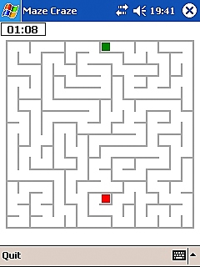

You seek me here, you seek me there ….. the object to find me ……. a hidden red square!

You are the green square; navigate yourself around the maze .... your destination is to meet the red square in the quickest time you can, before you run out of time!

Manoeuvre yourself around using the inbuilt D-pad/ joystick of your device. Once you meet the red square with your green square, an audible sound is played, and that is your task complete!

As the levels increase and get more difficult, so the maze complexity increases.

Speed is also the name of the game, not just navigation!

DAILY EXAMS
Speed training
Summary and a refresh of all the other aptitudes previously tested

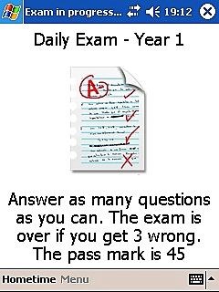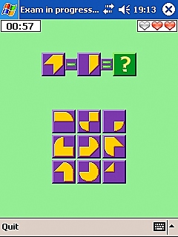

Speed is the key, this time around ….. the puzzles are familiar, but haste must abound!

The Daily Exams are accessed via: ‘Menu Button’ (on the Toolbar)

You have one Daily Exam for each year. They are an amalgamation of all the puzzles learnt in that year for years 1-3. Year 4 ‘Finals’ exam is an amalgamation of all the puzzles from your 4 years attendance at Brain School.

All the Daily Exams are timed which aids speed training, and once that time runs out your score will be displayed. This score will be the number you managed to answer correctly within the allotted time.
The required pass mark and the amount of time you have to complete the exam are displayed on the exam introduction screen.
Across all the exams you have 3 ‘lives’ …….. once you get 3 answers wrong the exam is automatically halted, and the mark based on the amount of answers you have managed to answer correctly up to that point.

Chart your progress time-wise via the timer in the top left hand corner of the screen. In the top right hand corner of the screen are 1-3 ‘♥’ symbols which indicate how many of your 1-3 ‘lives’ are remaining.

Your results will be graphed so you can chart your progress. This can be accessed via the Toolbar: Menu → School Reports → Year 1/ 2/ 3/ Finals Exam. You then have option to also → Graph all (shows your progress so far across ALL the exams).

If you receive a call, or some similar episode occurs on your device that interrupts your sitting of the exam, the exam will be paused and you will be sent back to the main screen. That exam will end there. In the event of this occurring, you just need to start an entirely fresh Daily Exam. Only your top score gets recorded for that day’s exam, so no impact on that will occur.

OTHER FEATURES

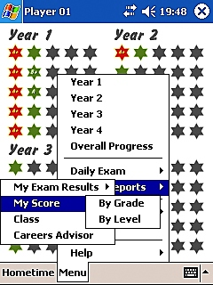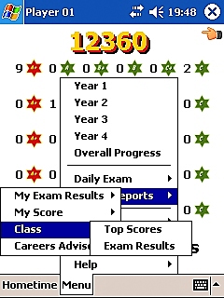

PAUSE FEATURE:
Gameplay will pause automatically if you receive a call or some similar episode occurs on your device. When you return to Brain School there will be a ‘paused’ screen displayed shown below;

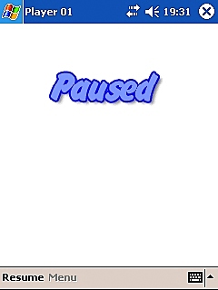

To resume play, hit the ‘resume’ button on the Toolbar.

PROGRESS SCREENS:

Brain School Overall Progress Screen: Shows progress for years 1-4. Each year shows the stars in a 5x5 grid, showing the top scores you have gained for each. Shown below:

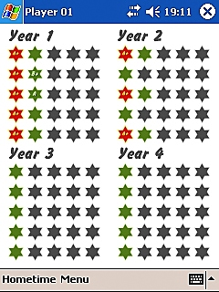

Anytime you want to view your Overall Progress Screen you click:
'Menu' (located on the Toolbar) →' Overall Progress'.

Tap on any year to zoom in on that year and to select a puzzle from that year.

Yearly Puzzles Progress screen: Shows an individual year’s progress and the progress for each puzzle in more detail. Each has a row of 5 stars for each level. Their colour/ text depict your top score for each level of that year's games. Shown below:

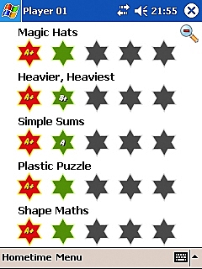

Star System:

GREY STAR: Shows levels/years not yet available to you.
GREEN STAR: Shows levels/years available to you, but not yet played.
GREEN STAR WITH GRADING TEXT: Shows levels/years played. Illustrates you have not yet reached the top A+ score, but shows your top score (e.g. B) for that puzzle level.
RED/ YELLOW STAR: You’ve achieved the top score on that puzzle level! These A+ stars are added together and help you unlock the next year’s puzzles, depending on the number required for that year.

NOTE: To switch from the yearly progress screen to the overall progress screen, click the ‘’ icon in the top right of the screen. To switch from the overall, back to the yearly progress screen, then click on the year’s star grid you wish to view.

Puzzle Level Information Screen: This is a designated information screen giving you information for that puzzle and the particular level. Shown below:

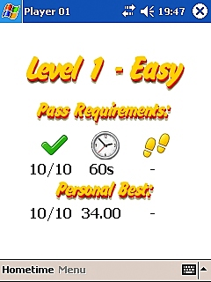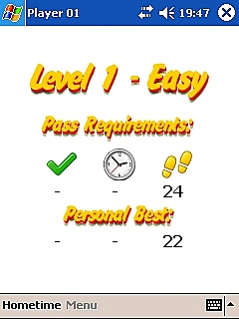

Each Puzzle Level Information Screen will tell you:
The LEVEL you're on and its requisite DIFFICULTY.
PASS REQUIREMENTS:
icon with a number below: How many questions you have to answer correctly for A+
icon with a number below: Amount of time available to you (e.g. 300 secs)
OR;
icon with a number below: The amount of moves available to you (e.g. as in ‘Twins’)
PERSONAL BEST:
Will give you the best score on that puzzle and the shortest amount of time you’ve completed it in to date.... Can you beat it?!

If at anytime you want to get rid of this screen faster, then simply click anywhere on this screen which will allow you to proceed to the puzzle gameplay quicker.

Puzzle Results Screen: After you’ve timed out/ completed a particular puzzle, you then have that puzzle’s results screen displayed. This screen displays your results from that previous session of play. Shown below:

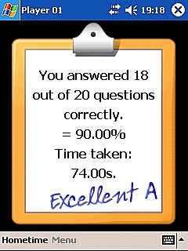

If at anytime you want to get rid of this screen faster, then simply click anywhere on this screen which will allow you to proceed quicker.

OPTIONS

MULTIPLE PLAYERS (PUPILS):
Accessed via: ‘Menu’ (located on the Toolbar) → ‘Options’ → ‘Pupil’ → ‘Change Pupil’
Each player’s individual scores, levels, etc are stored. The game can store information for up to 10 pupils (players).
Player currently playing is displayed along the top bar.
Each player name can be edited. (i.e. from ‘Player 02’ to ‘Adam’).
Accessed via: ‘Menu’ → ‘Options’ → ‘Pupil’ → ‘Edit Pupil’s Name’
Example below:

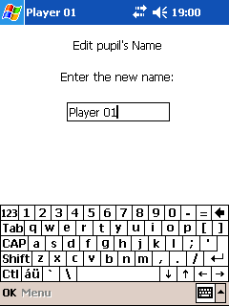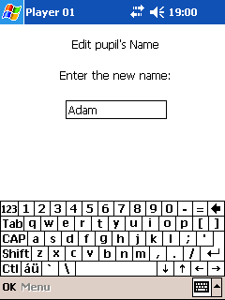

You can also either reset the scores to ‘clear’ of an individual pupil or all the pupils stored in Brain School
This can be accessed via: ‘Menu’ (located on the toolbar) → ‘Options’ → ‘Pupil’ → ‘Reset Current Pupil/ Reset ALL Pupils’

SOUNDS:

You can choose to turn off the background sound of the School Piano or The Brain School notification/ gameplay sounds …… or both!

You can access this via: ‘Menu’ (located on the toolbar) → ‘Options’ → ‘Audio’ → ‘Sounds On/ School Piano On’ (Just tick/ un-tick either option to select/ de-select).

SCHOOL REPORTS

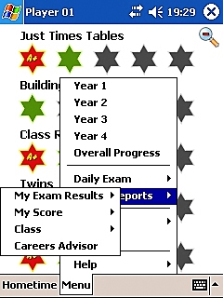

These are accessed via the ‘Menu’ button located on the Toolbar.
Exam Results, My Score, Class and Careers Advisor are then accessed separately from this ‘School Reports’ section.

My Exam Results

Chart your progress in the Daily Exams!!!!

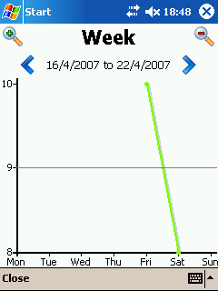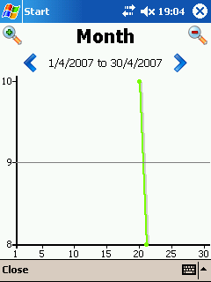

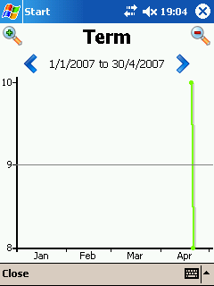

Accessed via:
Menu → School Reports → Year 1/2/3/Finals Exam then have option to also → Graph all

The results can be graphed as either; a Week’s Results, Month’s Results, or a Term's Results. To switch between these options click either of the magnifying glasses: '' (top left) or '' (top right).

To view the next or previous week/month/or term you are viewing click on either of the blue arrows shown below:
For Previous
For Next

Each Daily Exams Best day's score is charted on the vertical bar.
Each ‘School Day’ (Monday-Sunday)/ ‘School Month’ (5 day increments) / ‘School Term’ (monthly increments) is charted on the horizontal bar.

To exit graph mode click the 'close' button located on the Toolbar; you will then be taken back to the Overall Progress Screen.

My Score:
Your scores given as either a Grade or Level
Accessed via ‘Menu’ → ‘School Reports’ → ‘My Score’

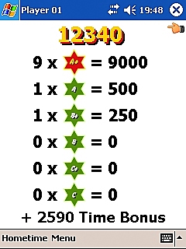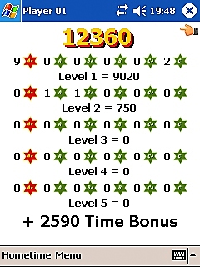

NOTE:
To switch back from this screen, click the ‘’ icon in the top right hand corner of the screen. This action will take you back to the Overall Progress Screen.

Class:
Top Scores and Exam Results of the Brain School Class (Players 01-10 stored on your device)!
Accessed via ‘Menu’ → ‘School Reports’ → ‘Class’

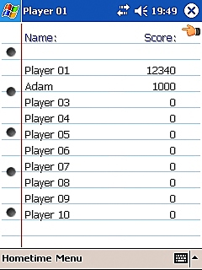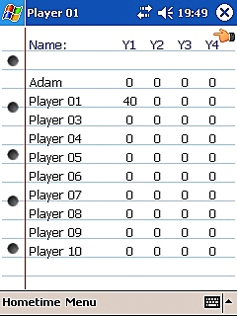

NOTE:
To switch back from this screen, click the ‘’ icon in the top right hand corner of the screen. Performing this action will take you back to the Overall Progress Screen.

Careers Advisor:

Careers Advice is always crucial …….. to make your job fun, as well as useful!

Accessed via ‘Menu’ → ‘School Reports’ → ’Careers Advisor’

An ideal career choice will be suggested to you based on your aptitudes shown so far on the various puzzles.



NOTE:
To switch back from this screen, click the ‘’ icon in the top right hand corner of the screen. You will then be taken back to the Overall Progress Screen.

EXTRA TUITION:


Extra Curricular Activities:

Mastersoft Kakuro
Mastersoft Suduko
Mastersoft Chess

These are ideal ‘homework’ and a useful fun adjunct to Brain School where you have just a taster of 2 of these award-winning titles. The full versions have many more features and a greater complexity than the ones included in Brain School and would help maximise your school results and brain potential!!! Kakuro and Sudoku are also available in desktop versions.

Lifestyle Tips:

Find the time for relaxation, restorative sleep, gentle exercise and leisure time because constant high stress hormone levels decrease brain function, in particular memory.

A healthy diet rich in vitamins, minerals, and especially essential fatty (from oily fish, nuts and seeds), and amino acids (from proteins), will also positively impact on your overall brain health and make sure that all its neurotransmitters are performing at their optimum levels!

We hope you have enjoyed your years at Brain School!

Remember to keep playing to keep your brain in tip-top shape!

Visit our website at:
www.MastersoftMobileSolutions.com

From there you can;
Check out our other great award-winning titles: Mastersoft Sudoku, Mastersoft Kakuro, Mastersoft Money, My Last Cigarette, Billable Buddy, Old School Classics … and … many, MANY more!!!!

Get involved in our friendly support forums;
Submit ideas, leave feedback on products, chat to other members, receive excellent support advice and help develop new titles too!

We’re here to help!!!!

Mastersoft Mobile Solutions
2007

